
Visual designs
Denas Malysevskis


Table of Contents
Visual Designs 3
Algorithm Design 3
Register Flowchart 3
Login Flowchart 5
Data Requirements Design 5
Test Strategy 5

Visual Designs

Algorithm Design

Register Flowchart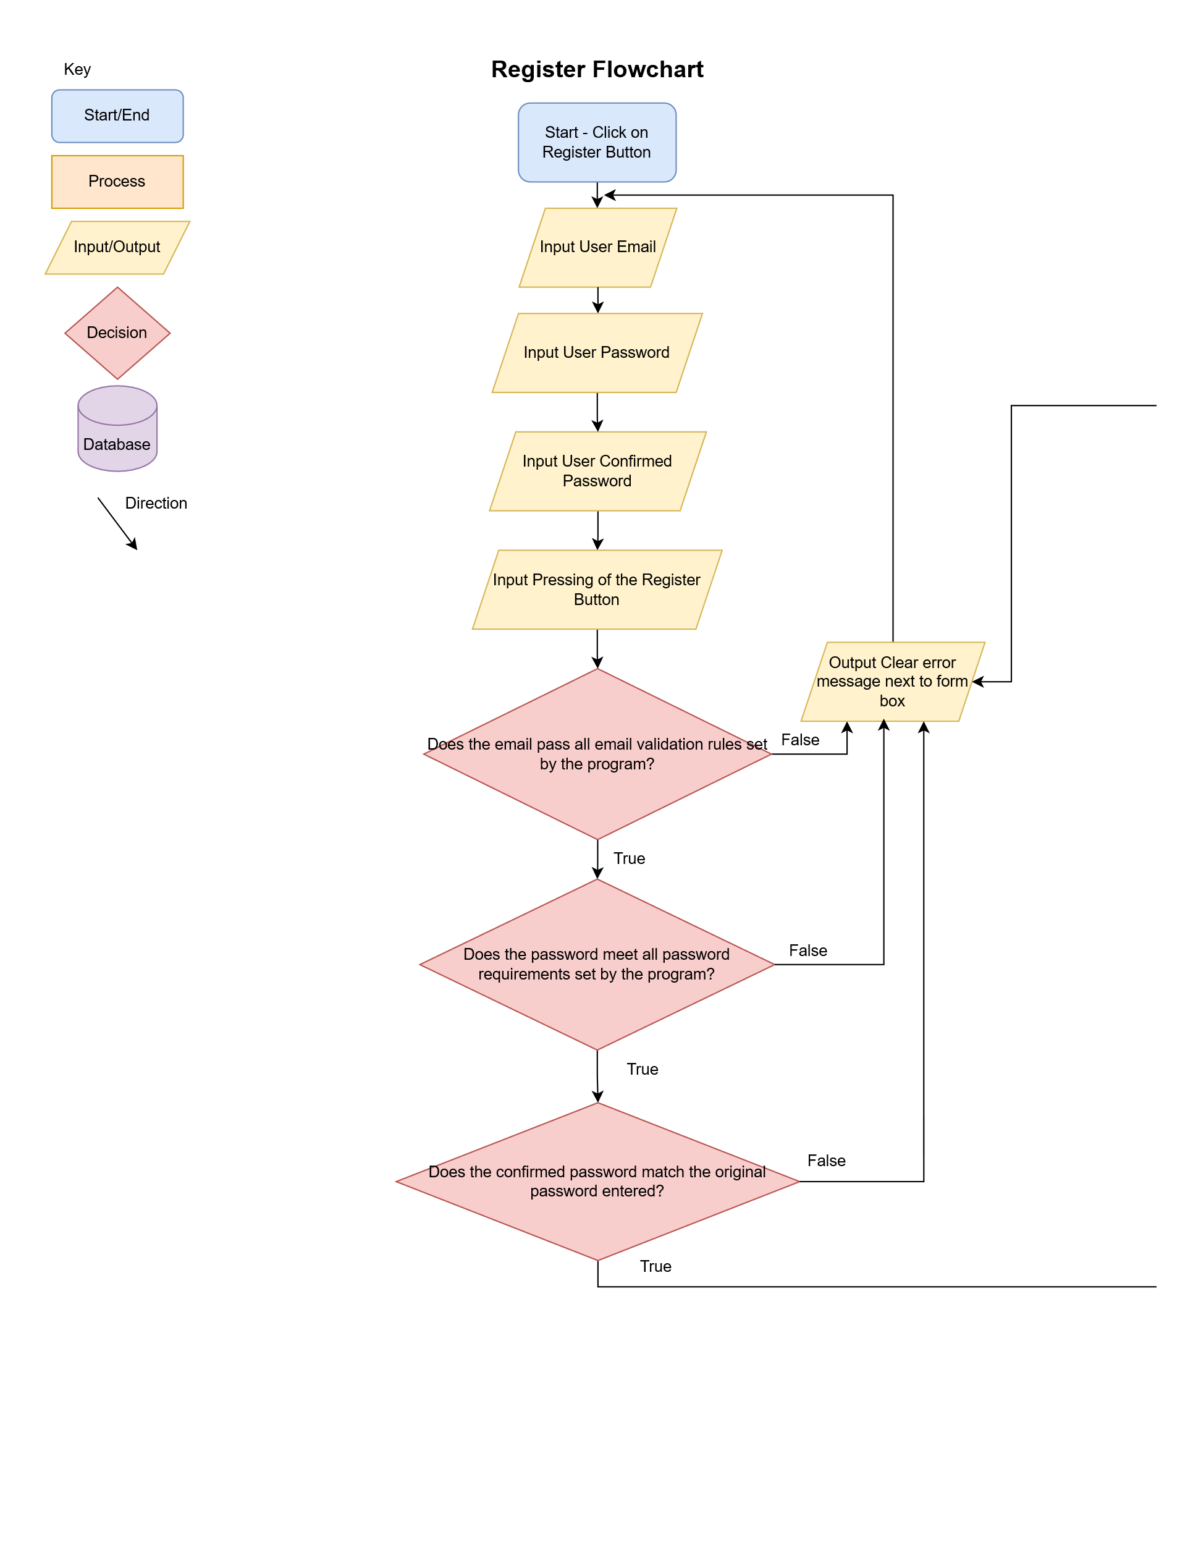
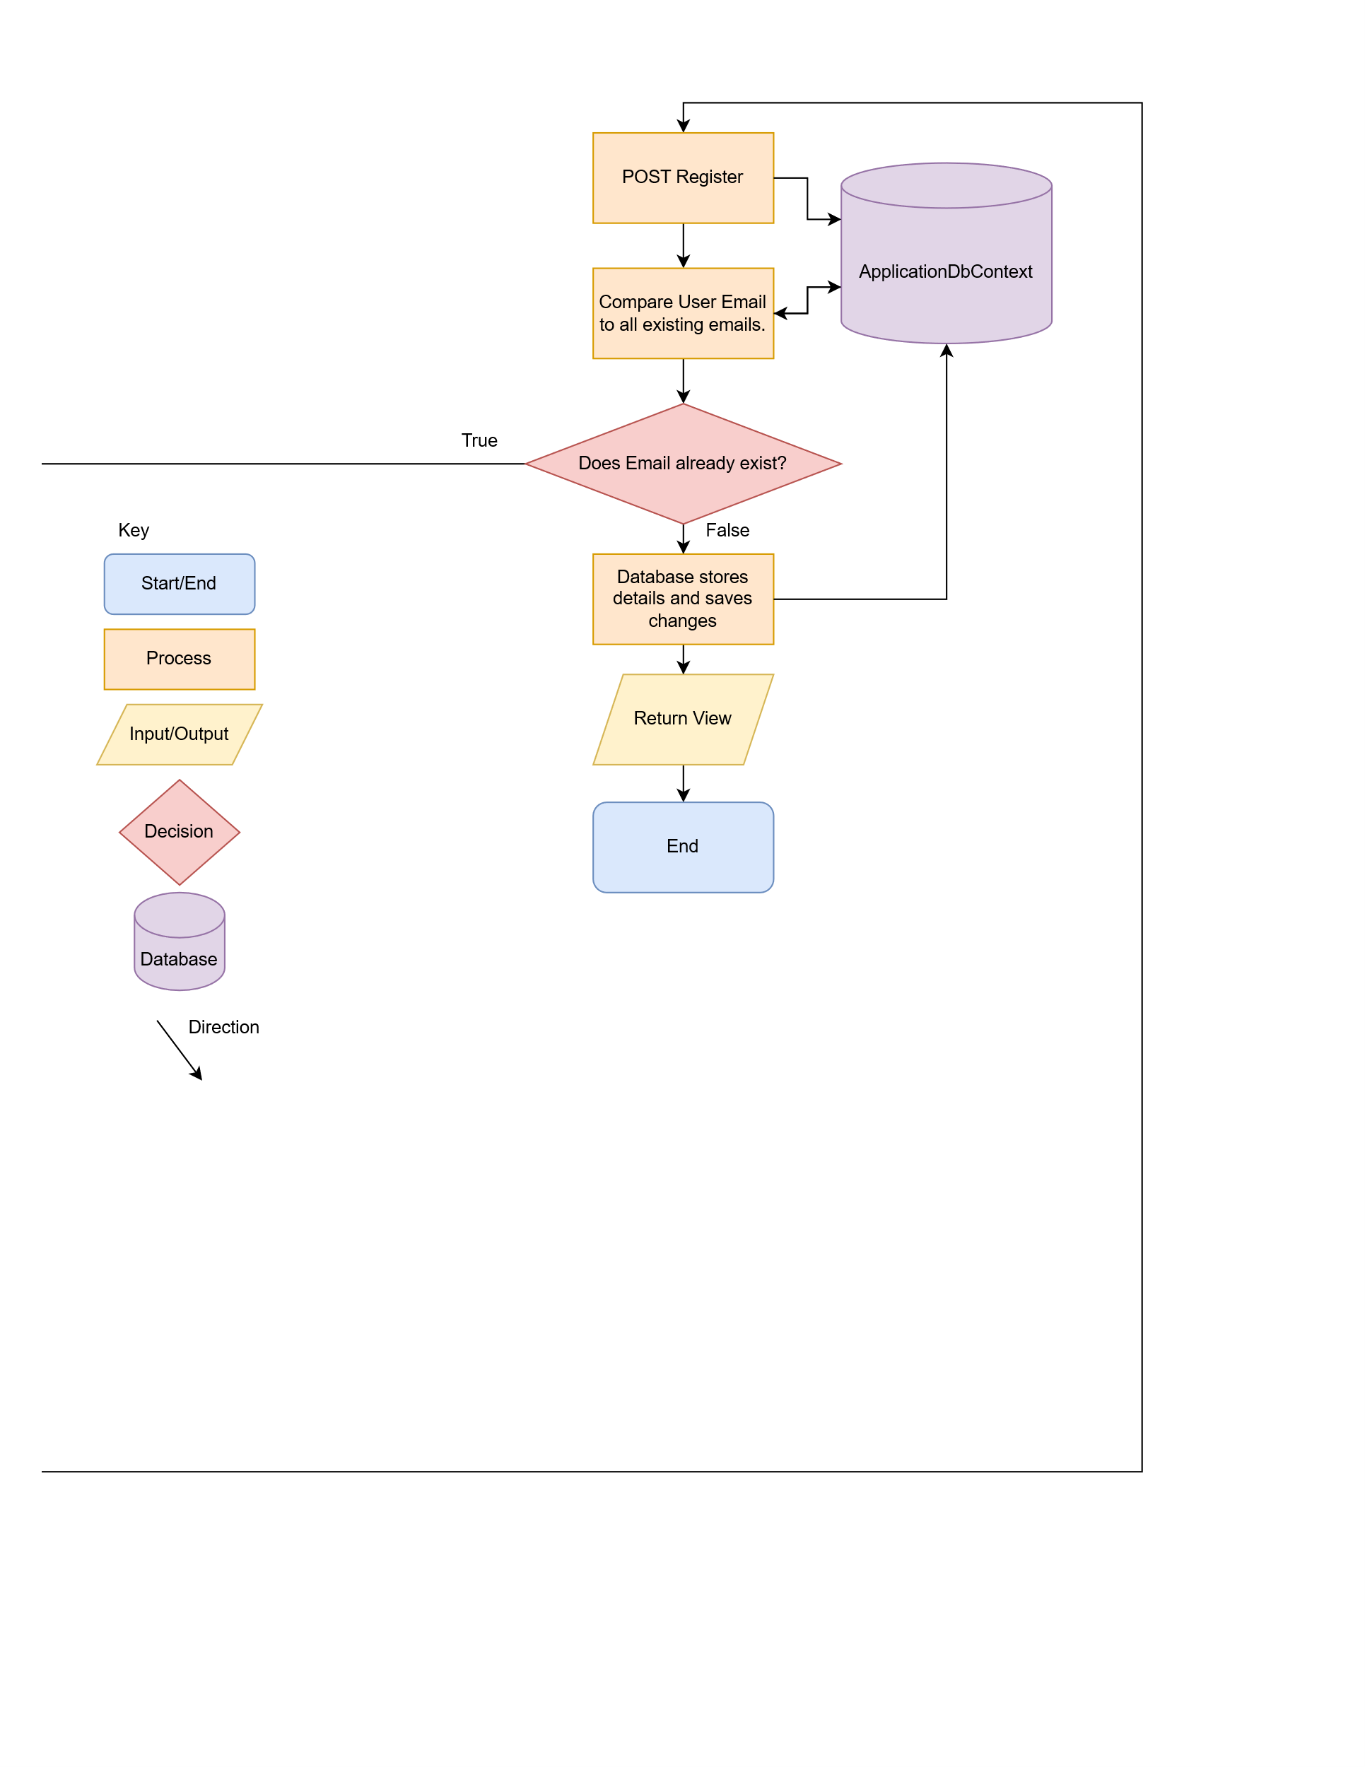
The user will be given a Form Box to input an email, a password and a confirmation password box. The details will then be validated, if any of the validation checks come back as false the user will be asked to retry. If the validation checks pass, the data will be sent through POST to the database. Then, the solution will compare to see if the email already exists. If the email already exists, the user will be prompted to use a different email or to sign in. If the email does not already exist, the details are saved in the SQL server database and the user is then returned to the view.

Login Flowchart
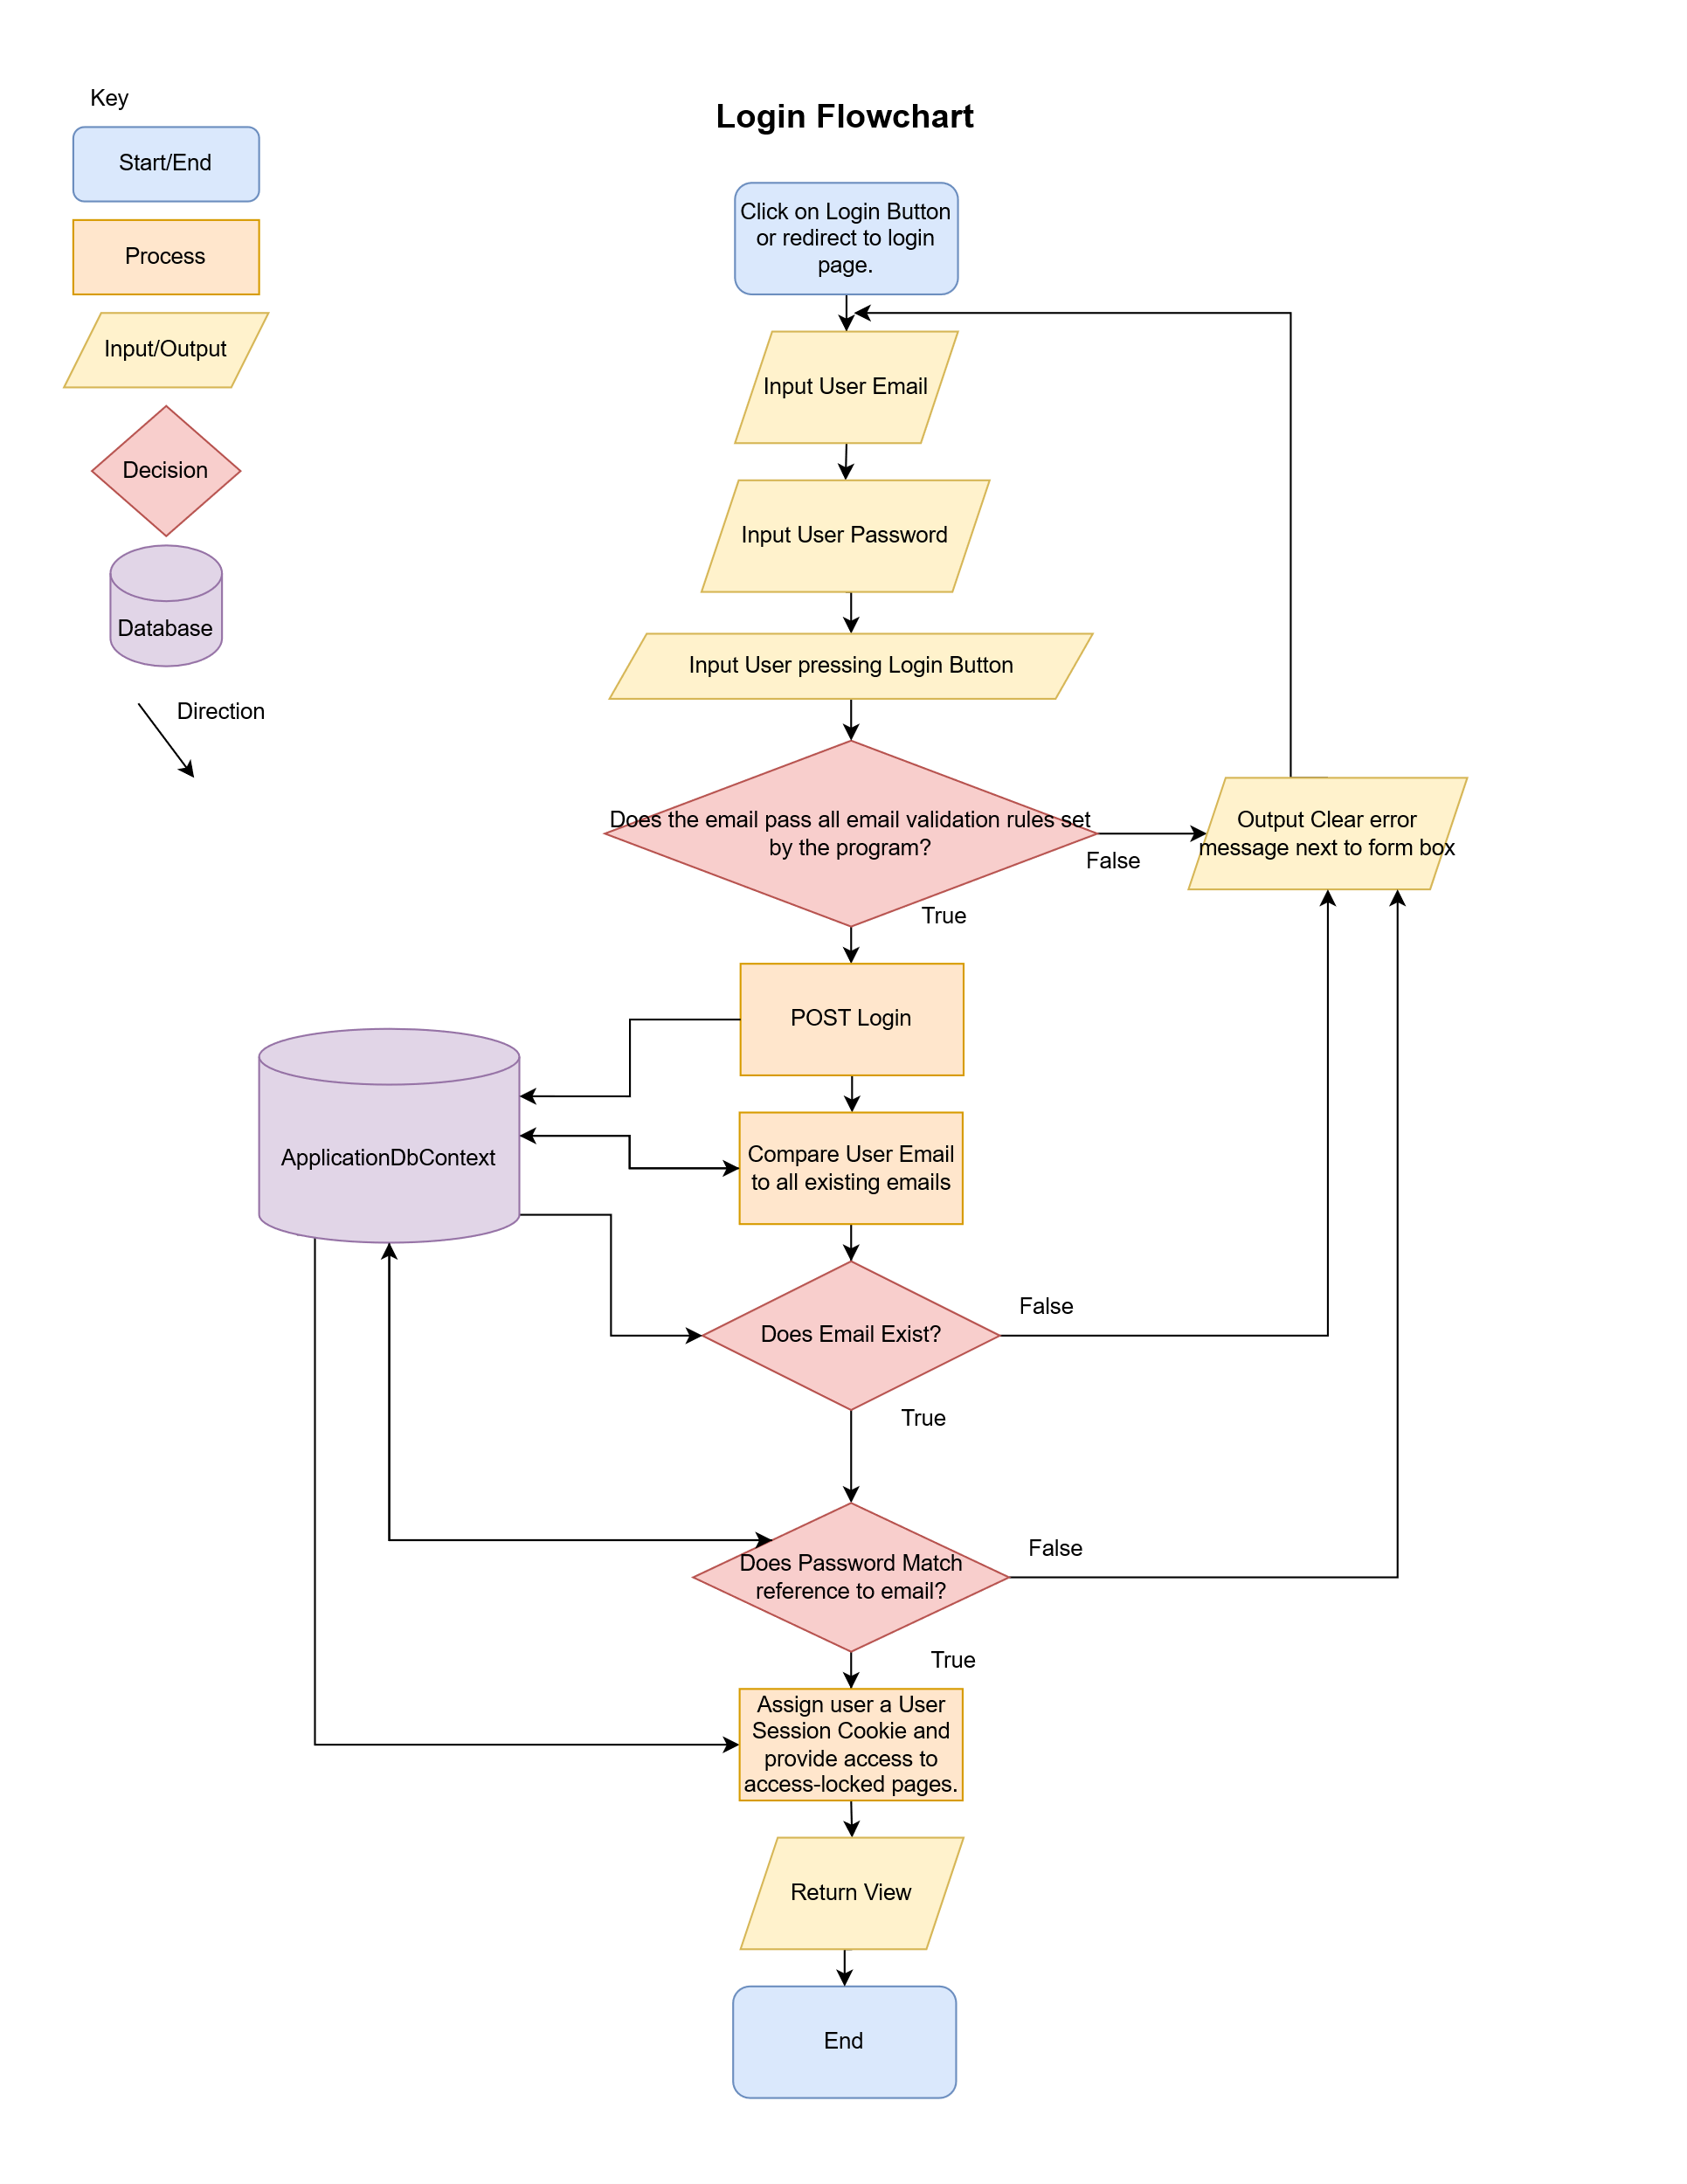
The user will be prompted to enter their email and password. The system will then validate

Data Requirements Design

Test Strategy

Column | Data Type | Required? | Default | Validation | Key Types

